Practical 3 – State Maintenance

Q1) Create a web form that records the number of times a button is clicked. The result is displayed in a Label control. The sample output is as shown in Figure 1.

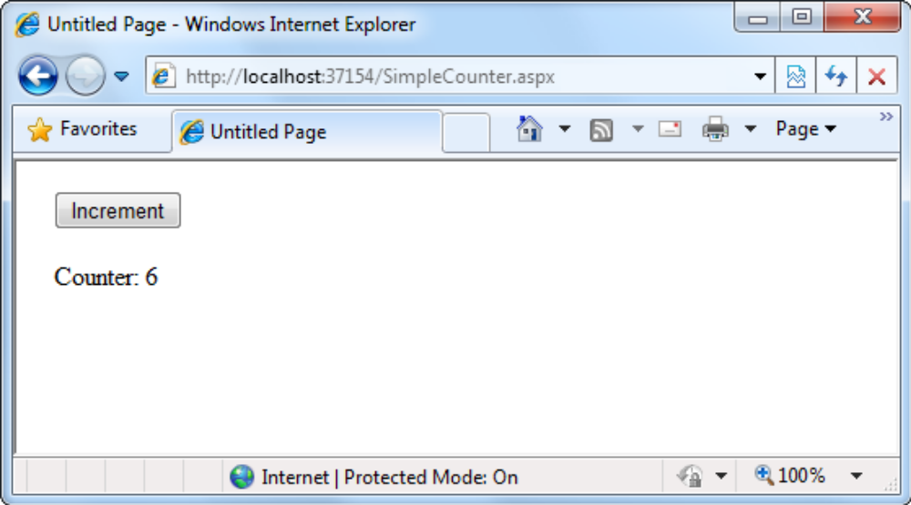
Figure 1

Ans:

Markup

<form id="form1" runat="server">
<div>
<asp:Button ID="btnIncrement" runat="server" Text="Increment" />
<br />
<br />
<asp:Label ID="lblResult" runat="server"></asp:Label>
</div>
</form>

VB Code

Protected Sub btnIncrement_Click(sender As Object, e As EventArgs) Handles btnIncrement.Click
Dim Counter As Integer
If ViewState("Counter") Is Nothing Then
Counter = 1
Else
Counter = CType(ViewState("Counter"), Integer) + 1
End If
ViewState("Counter") = Counter
lblResult.Text = "Counter: " & Counter.ToString()
End Sub

Q2) Create a web form with the design as shown in Figure 2.

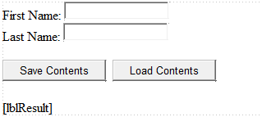
Figure 2

- The the Customer class that has two private member variables defined namely _firstName and _lastName. The data type for both the private member variables is String.
- When the “Save Contents” button is clicked, First Name and Last Name will be saved in the Customer object and both the text boxes will be cleared. When the “Load Contents” button is clicked, the Label conttrol will display the First Name and Last Name from the Customer object.

Ans:
(a)
<Serializable()> _
Public Class Customer
Private _firstName As String
Public Property FirstName() As String
Get
Return _firstName
End Get
Set(Value As String)
_firstName = Value
End Set
End Property
Private _lastName As String
Public Property LastName() As String
Get
Return _lastName
End Get
Set(Value As String)
_lastName = Value
End Set
End Property
Public Sub New()
Me.FirstName = ""
Me.LastName = ""
End Sub
Public Sub New(firstName As String, lastName As String)
Me.FirstName = firstName
Me.LastName = lastName
End Sub
End Class

(b)
Partial Class Q2
Inherits System.Web.UI.Page

Private myCustomer As New Customer()
Protected Sub btnSaveContents_Click(sender As Object, e As EventArgs) Handles btnSaveContents.Click
myCustomer.FirstName = txtFName.Text
myCustomer.LastName = txtLName.Text

txtFName.Text = ""
txtLName.Text = ""

End Sub

Protected Sub Page_Load(sender As Object, e As EventArgs) Handles Me.Load
If Me.IsPostBack Then
myCustomer = CType(ViewState("myCustomer"), Customer)
End If
End Sub

Protected Sub btnLoadContents_Click(sender As Object, e As EventArgs) Handles btnLoadContents.Click

lblResult.Text = myCustomer.FirstName & " " & myCustomer.LastName
End Sub

Protected Sub Page_PreRender(sender As Object, e As EventArgs) Handles Me.PreRender
ViewState("myCustomer") = myCustomer
End Sub
End Class

Q3) Create a web form that presents a list of entries as shown in Figure 3. When the user chooses an item by clicking the appropriate item in the list, the user is forwarded to a new page. This page displays the received item. The sample output is as shown in Figure 4.
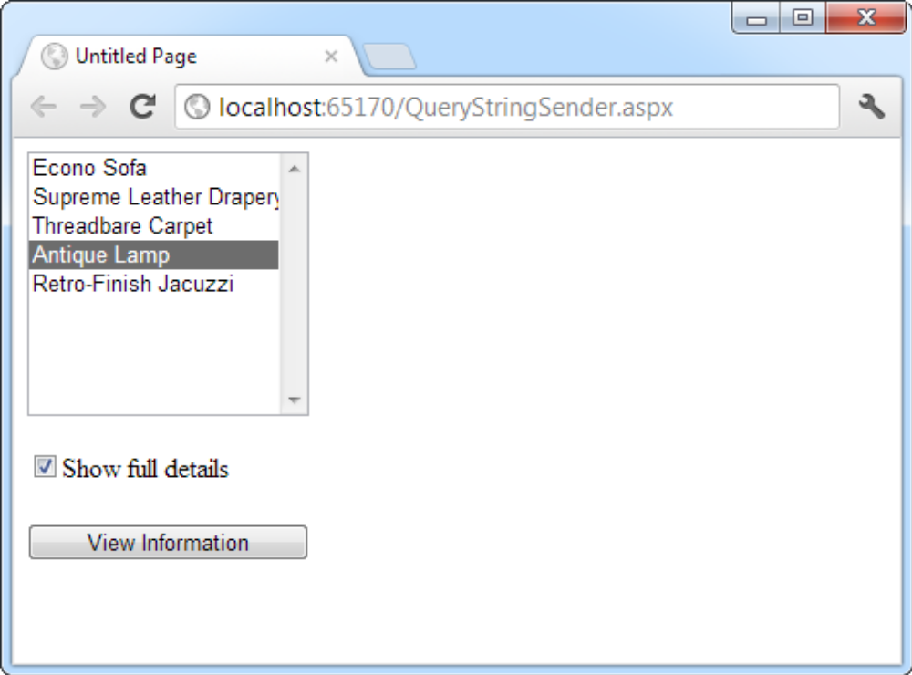
Figure 3
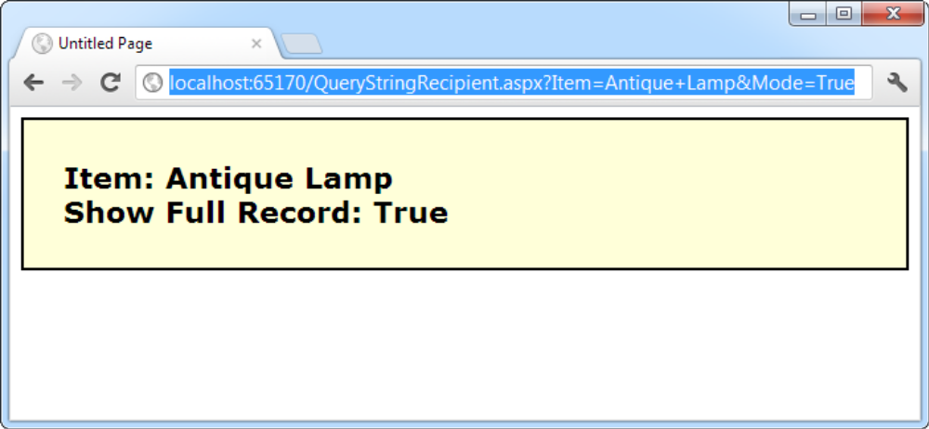
Figure 4
Ans:
Here’s the code for the first page:
Public Partial Class QueryStringSender
Inherits System.Web.UI.Page
Protected Sub Page_Load(sender As Object, _
e As EventArgs) Handles Me.Load
If Not Me.IsPostBack Then
' Add sample values.
lstItems.Items.Add("Econo Sofa")
lstItems.Items.Add("Supreme Leather Drapery")
lstItems.Items.Add("Threadbare Carpet")
lstItems.Items.Add("Antique Lamp")
lstItems.Items.Add("Retro-Finish Jacuzzi")
End If
End Sub
Protected Sub cmdGo_Click(sender As Object, _
e As EventArgs) Handles cmdGo.Click
If lstItems.SelectedIndex = −1 Then
lblError.Text = "You must select an item."
Else
' Forward the user to the information page,
' with the query string data.
Dim Url As String = "QueryStringRecipient.aspx?"
Url & = "Item = " & lstItems.SelectedItem.Text & "&"
Url & = "Mode = " & chkDetails.Checked.ToString()
Response.Redirect(Url)
End If
End Sub
End Class
Here’s the code for the recipient page (shown in Figure 8-7):
Public Partial Class QueryStringRecipient
Inherits System.Web.UI.Page
Protected Sub Page_Load(sender As Object, _
e As EventArgs) Handles Me.Load
lblInfo.Text = "Item: " & Request.QueryString("Item")
lblInfo.Text & = " < br />Show Full Record: "
lblInfo.Text & = Request.QueryString("Mode")
End Sub
End Class

Part 2: Do it yourself

Q4) Create the web form that will retrieve the user profile from the cookie and display the information in the web form. The design of the web form is as shown in figure. When the “Save” button is clicked, the user profile information will be saved into the cookie. The cookie will expire in 5 minutes from the time it was created.
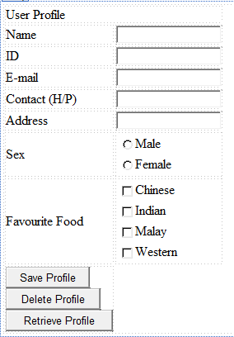

Q5) Create the web that shows the following information regarding sessions. The sample output of the web page is as shown in figure.
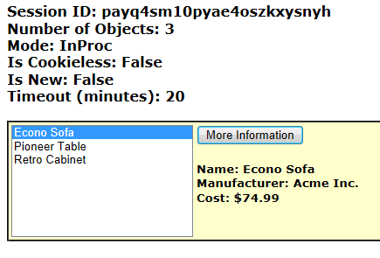
The out has information about the Session ID, Number of Session objects, the mode of the session state, whether the sessions require the use of cookies, whether the session was created in the current request, and the duration for the session to timeout. When the “more Information” button is clicked, the corresponding information will be obtained from the session variable to be displayed to the user.

